WORKSHEET #1
YOUR DESTINATION DYNAMICS
Destinations offer many activities, attractions, and opportunities to create experiences for visitors. Although it may be tempting to try to promote everything, it’s important to focus on what visitors find the most compelling about your region. While a variety of attractions and activities add to a destination, they may not all motivate travel. Consider the most competitive strengths of your destination to help inform your experience development ideas.
Consider these three categories of attractions and activities:
Demand generators: Iconic attractions and popular activities that motivate visitors to choose your destination over another.
Demand supporters: Attractions and activities that give visitors a variety of things to see and do in your area, making it more likely that they will choose to visit and stay longer.
Hidden gems: Though they may not be part of your destination’s known tourism offerings, hidden gems are often discovered once visitors arrive and can add value to their experience (local expert, unique talent, special location).
Cabot Trail considerations:

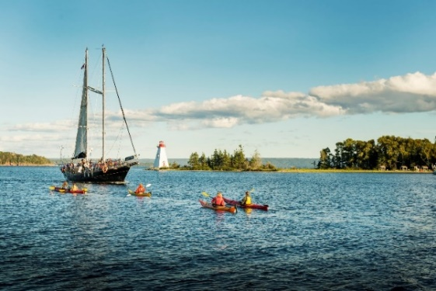
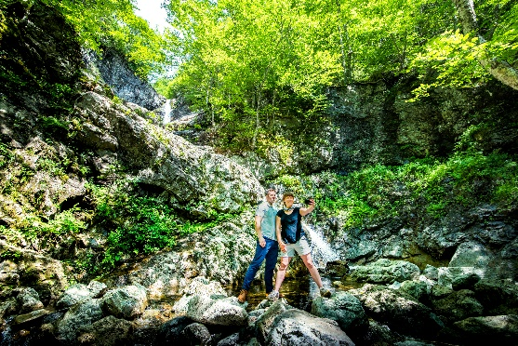

Demand Generator
The Cabot Trail
Demand Supporter
Amoeba Sailing Tours
North River Kayak Tours

Hidden Gem
Uisge Bàn Falls Provincial Park
As a demand generator, the Cabot Trail welcomes thousands of visitors each year and offers many reasons to visit. To help experience the iconic Cabot Trail from a unique perspective, visitors can take part in boat tours on the Bras d’Or Lake UNESCO Biosphere Reserve through local demand supporters, like Amoeba Sailing Tours and North River Kayak Tours. There are also numerous possible hidden gems in the area, such as Uisge Bàn Falls Provincial Park. Gaelic for “white water”, the gorgeous trail leading to a 16-metre waterfall may not be well known among travellers, but it offers visitors another incredible way to experience the natural beauty of the Cape Breton highlands.
What are the destination dynamics around the location of your business or experience offerings? The next steps of this worksheet will allow you to explore the demand generators, supporters, and the hidden gems of your region. Using the list of destination dynamics that you uncover, get creative brainstorming how you could leverage these assets to create a unique, authentic experience for your business.
DESTINATION DYNAMICS WORKSHEET
Be specific. Try not to list generic things, like ‘beautiful beaches’ or ‘hiking trails’ but identify each opportunity by name.
Demand Generators – What motivates visitors to choose your region over another?

Demand Supporters – What attractions, activities, and things to see and do strengthen the overall appeal of your destination?

Hidden Gems – What local expert, artisan, musician, special location, etc. have potential to add value to a visitor’s experience in your destination?

EXPERIENCE BRAINSTORM
With your destination’s Demand Generators, Demand Supporters, and Hidden Gems fresh in your mind, brainstorm as many possible experience ideas as you can in the space below. Consider gaps or opportunities that aren’t currently available to visitors that you could deliver or help create through your business or with a partner.

